Project-1

Problem Statement: Cybersecurity Risk Assessment Framework for Small Businesses

Presented by: Vir Kaviraj

Naviotech solutions private limited

Introduction
In today’s digital era, businesses increasingly rely on information technology to manage operations, store data, and deliver services. While this digital transformation has improved efficiency and scalability, it has also introduced significant cybersecurity risks. Small and Medium Enterprises (SMEs), in particular, have become prime targets for cyberattacks due to their limited security infrastructure, lack of specialized cybersecurity personnel, and constrained budgets. Unlike large organizations, SMEs often underestimate the importance of cybersecurity, making them more vulnerable to threats such as phishing, ransomware, malware, and data breaches.
Cybersecurity incidents can have severe consequences for SMEs, including financial losses, reputational damage, legal liabilities, and disruption of business operations. For example, a ransomware attack can lock critical data, halting business activities, while a data breach can expose sensitive customer information, leading to loss of trust and potential regulatory penalties. As cyber threats continue to evolve in complexity and frequency, it is essential for SMEs to adopt a structured approach to identify, evaluate, and mitigate these risks effectively.
The core objective of this project is to design a practical and scalable risk assessment model that evaluates cybersecurity risks based on factors such as likelihood and impact. The model enables organizations to assign risk scores, categorize threats into different levels (low, medium, high), and implement appropriate mitigation strategies. Additionally, the project incorporates a working model using tools like Excel to demonstrate how risk evaluation can be automated and visualized for better decision-making.
Furthermore, the project explores common cybersecurity risks faced by SMEs and proposes effective mitigation strategies, including the use of firewalls, multi-factor authentication, employee training, and regular data backups. A case study approach is also used to validate the effectiveness of the proposed model by applying it to a hypothetical or real SME environment.
In conclusion, this project highlights the importance of proactive cybersecurity practices in SMEs and demonstrates how a structured risk assessment framework can significantly enhance their security posture. By identifying vulnerabilities, assessing risks, and implementing targeted mitigation strategies, SMEs can reduce the likelihood of cyberattacks and ensure the continuity and reliability of their business operations.

Research on some common cybersecurity risks
1. Phishing Attacks:
Phishing is a type of social engineering attack in which cybercriminals attempt to deceive individuals into disclosing sensitive information such as usernames, passwords, banking details, or confidential business data. These attacks typically appear as legitimate communications from trusted sources like banks, service providers, or even internal company departments. SMEs are particularly vulnerable to phishing due to limited employee training and lack of advanced email security systems.
- How the Attack Works
- Attacker sends a fake email pretending to be from a trusted organization.
- Employee clicks a malicious link or attachment.
- Credentials or company data are stolen.
- Example
An employee receives an email claiming to be from the company bank requesting account verification.
- Impact on SMEs
- Unauthorized system access
- Financial fraud
- Data breaches
- Prevention
- Employee security awareness training
- Email filtering systems
- Multi-factor authentication (MFA)

2. Ransomware:
Ransomware is a type of malicious software (malware) designed to block access to a system, files, or network and demand payment (ransom) to restore access. It is one of the most damaging cybersecurity threats, especially for organizations like SMEs, hospitals, and enterprises.
Once it infects a system, ransomware typically:
- Encrypts files using strong cryptographic algorithms
- Locks users out of their systems or data
- Displays a ransom note demanding payment (usually in cryptocurrency like Bitcoin)
- Threatens data deletion or public release if payment isn’t made
- Types of Ransomware
1. Crypto Ransomware (Most common)
- Encrypts files
- Example: WannaCry
2. Locker Ransomware
- Locks entire system/device
- User cannot access OS
3. Double Extortion Ransomware
- Encrypts data + steals it
- Threatens to leak sensitive data
4. Ransomware-as-a-Service (RaaS)
- Hackers sell ransomware tools on the dark web
- Even non-experts can launch attacks
- Impact on SMEs
- Loss of business operations
- Data loss
- Financial damage
- Prevention
- Regular backups
- Antivirus and endpoint protection
- System updates and patches
3. Malware Attacks:
Malware is any software intentionally designed to damage, disrupt, steal data, or gain unauthorized access to computer systems, networks, or devices.Types of malware include:
- Viruses
- Trojans
- Spyware
- Worms
- What Malware Does
Depending on its type, malware can:
- Steal sensitive data (passwords, banking info)
- Spy on user activity
- Corrupt or delete files
- Slow down or crash systems
- Take control of devices (botnets)
- Spread across networks
- Impact on SMEs
- System damage
- Data theft
- Unauthorized access
- Prevention
Basic Security
- Install antivirus/anti-malware software
- Avoid suspicious links and attachments
- Download software only from trusted sources
Advanced Security
- Keep systems updated (patch management)
- Use firewalls and intrusion detection systems
- Implement MFA and access control
- Regular backups
- Employee awareness training
4. Password Attacks
Weak passwords allow attackers to gain unauthorized access to company accounts.
Common password attack methods include:
- Brute force attacks
- Credential stuffing
- Password guessing
- Real-World Example
LinkedIn Data Breach (2012)
- Millions of passwords leaked
- Many were weak or reused
- Attackers reused them on other platforms (credential stuffing)
- Impact
- Account compromise
- Data breaches
- Unauthorized transactions
- Prevention
- Strong password policies
- Password managers
- Multi-factor authentication

5. Data Breaches:
A data breach is a security incident in which unauthorized individuals access, steal, or expose sensitive, confidential, or protected data.
This data can include:
- Personal information (names, addresses, Aadhaar, phone numbers)
- Login credentials (usernames, passwords)
- Financial data (credit/debit card details, bank info)
- Business data (trade secrets, internal documents)
- Causes
- Poor access control
- Weak passwords
- Insider threats
- Impact
- Financial loss
- Legal penalties
- Loss of customer trust
- Prevention
- Data encryption
- Access control policies
- Security monitoring

Risk assessment model
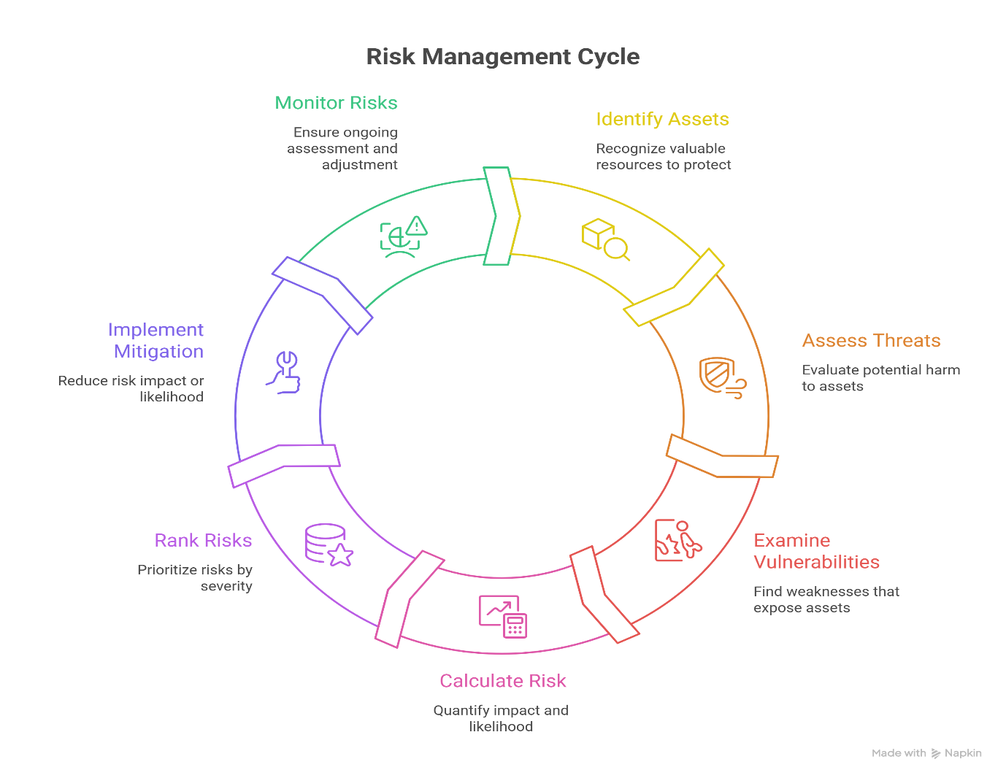
1. Identify Assets
- Create an asset inventory (hardware, software, data, people, processes).
- Assign asset value based on:
  - Confidentiality (sensitivity of data)
  - Integrity (importance of accuracy)
  - Availability (uptime requirements)
- Use classification levels: Public, Internal, Confidential, Critical.
- Example: Banking system → High confidentiality + high availability.

2. Assess Threats
- Categorize threats:
  - Natural: floods, earthquakes
  - Technical: system failures, malware
  - Human: insider misuse, social engineering
- Identify threat actors:
  - Script kiddies, cybercriminals, nation-state attackers
- Map threats to assets (threat modeling).
- Example: Database → Threat: SQL injection attack.

3. Examine Vulnerabilities
- Perform vulnerability assessments and penetration testing.
- Types of vulnerabilities:
  - Technical (unpatched OS, open ports)
  - Human (lack of awareness)
  - Process (no backup policy)
- Use tools like vulnerability scanners (conceptually).
- Example: Outdated software → exploitable bug.

4. Calculate Risk
- Quantitative approach:
  - Risk = Probability × Impact
- Qualitative approach:
  - Use categories like Low, Medium, High, Critical
- Advanced metrics:
  - SLE (Single Loss Expectancy)
  - ALE (Annual Loss Expectancy)
- Helps justify security investment decisions.

5. Rank Risks
- Use risk matrix (heat map):
  - High impact + High likelihood → Top priority
- Consider:
  - Business impact
  - Regulatory/legal implications
- Enables efficient resource allocation.
- Example: Data breach > minor downtime.

6. Implement Mitigation
- Risk treatment strategies:
  - Avoid: Stop risky activity
  - Reduce: Apply controls
  - Transfer: Insurance, outsourcing
  - Accept: If risk is low
- Security controls:
  - Administrative (policies, training)
  - Technical (firewalls, IDS/IPS)
  - Physical (locks, CCTV)
- Example: Enable MFA to reduce account compromise risk.

7. Monitor Risks
- Continuous monitoring using:
  - Logs, SIEM systems, alerts
- Conduct:
  - Regular audits
  - Security reviews
  - Incident response updates
- Adapt to:
  - New vulnerabilities
  - Emerging threats
- Example: Detect unusual login activity in real-time.

risk evaluation metric
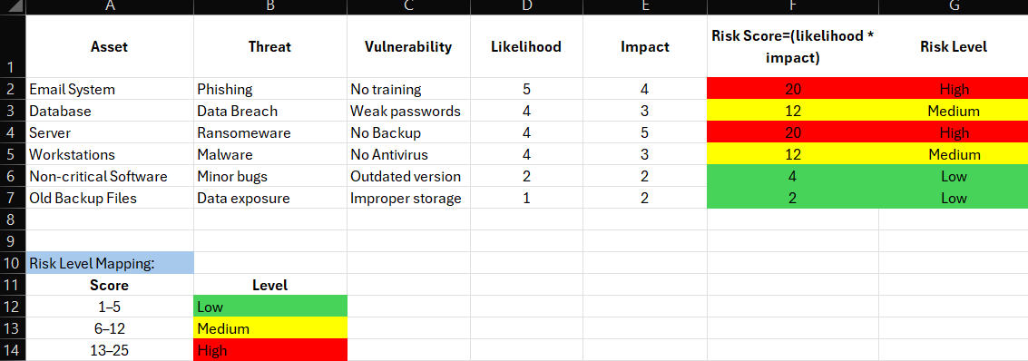

1. Structure of the Table
The table contains the following columns:
- Asset → System or resource being protected (e.g., Email System, Server)
- Threat → Possible attack (e.g., Phishing, Ransomware)
- Vulnerability → Weakness exploited (e.g., No training, Weak passwords)
- Likelihood (1–5) → Probability of the threat occurring
- Impact (1–5) → Severity of damage if it occurs
- Risk Score → Calculated value (Likelihood × Impact)
- Risk Level → Categorized as Low, Medium, or High
2. Risk Calculation Method
The model uses the formula:
Risk Score = Likelihood × Impact
This converts risks into numerical values for easy comparison.
3. Risk Level Classification (Color-Based)
The table uses color coding to represent risk severity:
- 🔴High Risk (13–25)
  - Example:
    - Email System (Phishing): 5 × 4 = 20
    - Server (Ransomware): 4 × 5 = 20
  - These require immediate action
- 🟡 Medium Risk (6–12)
  - Example:
    - Database (Data Breach): 4 × 3 = 12
    - Workstations (Malware): 4 × 3 = 12
  - These require monitoring and improvement
- 🟢 Low Risk (1–5)
  - Example:
    - Non-critical Software: 2 × 2 = 4
    - Old Backup Files: 1 × 2 = 2
  - These are acceptable risks

4. Key Observations from the Image
- High risks are associated with critical systems and major threats
- Medium risks indicate moderate vulnerabilities that need attention
- Low risks are less impactful and lower priority
- The model clearly highlights where security efforts should be focused

5. Importance of This Model
This risk evaluation metric helps organizations to:
- Prioritize cybersecurity threats
- Allocate resources efficiently
- Reduce major risks first
- Improve overall security posture

Risk Mitigation Strategies
Risk mitigation strategies are measures implemented to reduce the likelihood and impact of cybersecurity threats. For SMEs, an effective mitigation approach combines technical controls, administrative policies, and human awareness to build a strong security posture. These strategies ensure that even if an attack occurs, its impact is minimized and recovery is faster.
1. Technical Mitigation Strategies
These involve using security tools and technologies to protect systems and data.
1.1 Firewalls
Firewalls act as a protective barrier between internal networks and external threats. They monitor and filter incoming and outgoing traffic based on predefined rules.
Purpose:
- Block unauthorized access
- Prevent malicious traffic from entering the network
Benefit for SMEs:
- Protects critical systems like databases and POS systems
- Reduces exposure to external attacks

1.2 Multi-Factor Authentication (MFA)
Multi-Factor Authentication requires users to verify their identity using multiple factors such as passwords and OTPs.
Purpose:
- Strengthen login security
- Prevent unauthorized account access
Benefit:
Even if login credentials are stolen, attackers cannot access the system without additional verification.

1.3 Encryption
Encryption converts sensitive data into an unreadable format, ensuring that even if data is intercepted, it cannot be understood.
Types:
- Data at rest (stored data)
- Data in transit (data being transferred)
Benefit:
Protects sensitive information like customer data and financial records.

1.4 Antivirus and Anti-Malware Software
These tools detect and remove malicious programs such as viruses, worms, and ransomware.
Purpose:
- Protect systems from malware infections
- Monitor suspicious activities

2. Administrative Mitigation Strategies
These include policies, procedures, and management practices that guide secure behavior.
2.1 Employee Training and Awareness
Employees are often the weakest link in cybersecurity. Training programs help them recognize threats like phishing and avoid risky behavior.
Topics Covered:
- Identifying phishing emails
- Safe internet practices
- Password management
Benefit:
Reduces human errors that lead to cyber incidents.

2.2 Strong Password Policies
Organizations should enforce:
- Minimum password length
- Use of complex characters
- Regular password changes
Benefit:
Prevents unauthorized access due to weak credentials.

2.3 Access Control (RBAC)
Role-Based Access Control ensures that employees can only access data necessary for their role.
Benefit:
- Reduces insider threats
- Limits exposure of sensitive data

3. Operational and Recovery Strategies
These strategies focus on handling and recovering from cyber incidents.

3.1 Data Backup and Recovery
Regular backups ensure that data can be restored in case of loss or ransomware attacks.
Types:
- Cloud backups
- Offline backups
Benefit:
Minimizes data loss and downtime.

3.2 Incident Response Plan
A predefined plan to handle security incidents effectively.
Steps:
- Identify the attack
- Contain the damage
- Eliminate the threat
- Recover systems
Benefit:
Reduces response time and limits impact.

3.3 Regular System Updates and Patching
Updating software ensures that known vulnerabilities are fixed.
Benefit:
Prevents attackers from exploiting outdated systems.

4. Integrated Approach using NIST Cybersecurity Framework
Mitigation strategies align with:
- Protect: Firewalls, MFA, encryption
- Detect: Monitoring, antivirus
- Respond: Incident response plans
- Recover: Backup and restoration

Validation of Model on Case Studies on Different Businesses
- The validation process is conducted to ensure that the proposed risk assessment model is practical, accurate, and applicable to real-world SME environments.
- Case studies are selected from different types of businesses such as:
  - Retail stores
  - Small IT companies
  - Healthcare clinics
- For each business, critical assets are identified, including:
  - Customer databases
  - POS systems
  - Employee workstations
  - Network infrastructure
- Potential threats and vulnerabilities associated with each asset are analyzed.
Example:
  - Phishing attacks in email systems
  - Malware in POS systems
  - Weak passwords in employee accounts
- The developed risk assessment model is applied by assigning:
  - Likelihood values (1–5)
  - Impact values (1–5)
- Risk scores are calculated using:
  - Risk Score = Likelihood × Impact
- Based on the calculated scores, risks are categorized into:
  - Low risk
  - Medium risk
  - High risk
- The results are analyzed to check whether:
  - High-risk threats (e.g., phishing, ransomware) receive higher scores
  - Lower risks are categorized appropriately
- Appropriate mitigation strategies are suggested based on risk levels:
  - High risk → Immediate action (MFA, firewalls, training)
  - Medium risk → Monitoring and improvements
  - Low risk → Acceptable or minimal action
- The effectiveness of the model is evaluated by verifying that:
  - It identifies critical risks accurately
  - It prioritizes risks logically
  - It provides useful mitigation recommendations
- The validation confirms that the model is:
  - Reliable
  - Practical for SMEs
  - Useful for improving cybersecurity posture

Document Findings for Best Practices for SME Cybersecurity
Documenting Findings:
- The findings of the project are documented to summarize the results obtained from the risk assessment and case studies.
- It is observed that SMEs are highly vulnerable to common cybersecurity threats such as:
  - Phishing attacks
  - Ransomware
  - Malware infections
  - Weak authentication practices
- The risk assessment model successfully identifies and categorizes risks into:
  - Low
  - Medium
  - High
- High-risk areas are typically associated with:
  - Lack of employee awareness
  - Weak passwords and absence of MFA
  - Outdated systems and software
  - Unsecured networks
- Medium risks are linked to:
  - Misconfigured systems
  - Inadequate monitoring
  - Limited access control
- Low risks are generally related to:
  - Non-critical systems
  - Minimal operational impact assets
- The application of the model across different case studies shows that:
  - Phishing and ransomware consistently rank as high-risk threats
  - Proper mitigation strategies significantly reduce risk levels
- The findings confirm that a structured risk assessment approach helps SMEs:
  - Identify vulnerabilities
  - Prioritize security efforts
  - Improve overall cybersecurity posture

Best Practices for SME Cybersecurity (Points)
1. Implement Strong Authentication
- Use Multi-Factor Authentication (MFA) for all critical systems
- Enforce strong password policies

2. Conduct Employee Training
- Educate employees about:
  - Phishing attacks
  - Safe browsing practices
- Conduct regular awareness programs

3. Use Firewalls and Security Tools
- Install and configure firewalls
- Use antivirus and anti-malware software

4. Regular Data Backup
- Maintain regular backups of critical data
- Store backups securely (preferably offline or cloud)

5. Keep Systems Updated
- Regularly update operating systems and software
- Apply security patches to fix vulnerabilities

6. Secure Network Infrastructure
- Use strong Wi-Fi passwords
- Enable encryption (WPA2/WPA3)
- Restrict unauthorized access

7. Implement Access Control (RBAC)
- Provide access based on roles
- Limit access to sensitive data

8. Monitor and Log Activities
- Track system activities and login attempts
- Identify suspicious behavior early

9. Develop an Incident Response Plan
- Prepare steps to handle cyber incidents
- Ensure quick response and recovery

10. Use Encryption
- Protect sensitive data during storage and transmission

- The documented findings highlight the critical cybersecurity risks faced by SMEs and emphasize the importance of structured risk assessment. By adopting best practices such as strong authentication, employee training, and regular system updates, SMEs can significantly reduce vulnerabilities and enhance their overall security framework.

Conclusion
This project focused on creating a Cybersecurity Risk Assessment Framework for SMEs to help small businesses identify and manage cybersecurity risks. SMEs are often targeted by cyberattacks because they have limited security systems and awareness.
In this project, common threats like phishing, ransomware, and malware were studied. A risk assessment model was developed using likelihood and impact to calculate risk scores and classify risks as low, medium, or high. This helped in identifying the most critical risks.

Different mitigation strategies such as firewalls, multi-factor authentication, employee training, and data backups were suggested to reduce these risks. The model was also tested using case studies, which showed that it works effectively in real-world situations.
An Excel-based working model was created to automate risk calculation and make the process easier and more practical.
In conclusion, this project helps SMEs understand their cybersecurity risks and take proper actions to protect their systems and data.

reference
- https://www.researchgate.net/publication/390626662_Ransomware_Attacks_on_Critical_Infrastructure_Effects_and_Prevention_Strategies
- https://majmuah.com/journal/index.php/bij/article/view/458/224
- https://www.ijert.org/research/ransomware-threats-IJERTCONV8IS15015.pdf

